**INSTITUTE OF AERONAUTICAL ENGINEERING DUNDIGAL, HYDERABAD.**



**TWO WEEKS SUMMER INTERNSHIP ON**

**FOOD WEBSITE(WEB APPLICATION)**

**BY**

**GURRAM ANKIT**

**20951A0415**

**ECE**

**UNDER THE GUIDENCES**

**OF**

**SURYA NARYANA SIR**

|  |  |
| --- | --- |
| **S.NO** | **CONTEXT** |
| 1 | Title |
| 2 | Abstract:  Brief introduction  Existing System  Proposed System |
| 3 | Introduction |
| 4 | Literature Survey |
| 5 | Proposed System |
| 6 | Results |
| 7 | Conclusion |

Food website is an innovative and user-friendly food website that provides a seamless food ordering experience with a wide variety of cuisines to choose from. Our platform prioritizes convenience, offering secure online payment options while ensuring customer satisfaction.

**Key Features**:

* **Online Food Ordering**: Food website allows users to browse through a vast selection of restaurants and easily place food orders with just a few clicks.
* **Card Payment Option**: Customers can securely pay for their orders using credit or debit cards, making the payment process quick and hassle-free.
* **Administrator Access**: The administrator has full control over the platform and can manage and edit all data, including restaurant listings, menu details, and customer information.
* **Food Donation Page**: Food website has a special feature dedicated to food donations, allowing users to contribute meals to those in need. This page serves as a platform to connect generous donors with people who are hungry and in need of food.
* **Customer Registration**: New customers can easily register on Food website to create an account, enabling them to save their preferences, track orders, and enjoy personalized services.
* **Ticket System**: Food website offers a ticket-raising option for customers to submit queries, feedback, or concerns. Our dedicated support team ensures timely resolution of any issues.
* **Order Status Updates**: Customers can check the status of their orders in real-time. Whether it's "confirmed," "preparing," or "out for delivery," users stay informed about their food's progress.
* **Wallet Option**: Food website provides a wallet feature where users can add funds to their accounts, making future transactions faster and more convenient.
* **Cash on Delivery**: We understand that some customers prefer paying cash upon delivery. Food website offers this option to cater to different payment preferences.
* **Profile Editing:** Customers can easily update their personal information, delivery addresses, and payment details through the "Edit Details" option. This ensures accuracy and convenience when placing orders.

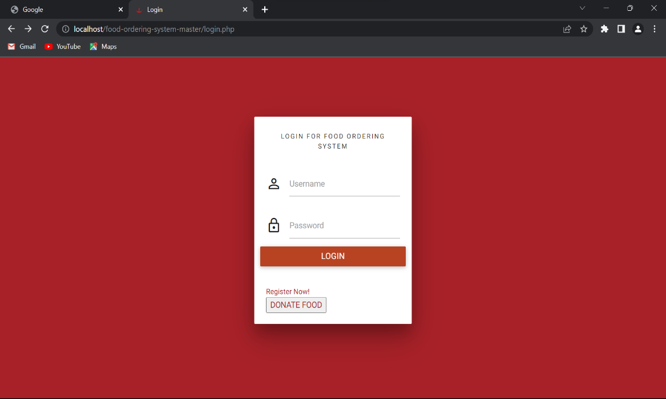

Food website aims to enhance your food ordering experience by combining user-friendly features, secure payment options, and the opportunity to contribute to the well-being of others through food donations.

Technologies and features that could be employed to develop a food ordering website with the mentioned functionalities:

1. **Front-end Development**: HTML, CSS, JavaScript, and popular frameworks like React, Angular, or Vue.js can be used for creating an interactive and responsive user interface.
2. **Back-end Development**: Programming languages such as Python, Ruby, or Node.js, along with frameworks like Django, Ruby on Rails, or Express.js, can be utilized to build the server-side logic and handle data processing.
3. **Database Management**: Relational databases like MySQL, PostgreSQL, or Oracle, or NoSQL databases like MongoDB or Cassandra, can be used to store and manage various data related to restaurants, menus, customers, orders, and user profiles.
4. **Payment Gateway Integration**: Services like Stripe, PayPal, or Braintree provide APIs and SDKs to securely handle online payments, including card payments.
5. **Content Management System (CMS):** Platforms like WordPress or Drupal can be customized to manage website content, including restaurant details, menu items, and donation page content.
6. **Ticketing System**: Implementing a ticketing system can be achieved using various tools like Zendesk, Freshdesk, or custom-built solutions to track and manage customer inquiries and support requests.
7. **Real-time Order Tracking**: Technologies like WebSocket or Server-Sent Events (SSE) can be used to provide real-time order status updates to customers.
8. **User Authentication and Authorization**: Implementing secure user registration, login, and access control can be achieved using authentication frameworks and libraries such as OAuth, JWT (JSON Web Tokens), or sessions.
9. **SMS and Email Notifications**: Integration with SMS gateways and email service providers can be utilized to send order confirmations, delivery updates, and other notifications to customers.

It's important to note that specific statistics and usage data for these technologies may vary, and their implementation would depend on the specific requirements and preferences of the food website. Additionally, advancements in technology and the availability of newer frameworks and tools could further enhance the development process and user experience.

Certainly! Here is a list of some popular competitors in the food delivery and ordering industry:

* **Uber Eats**: Uber Eats is a prominent player in the food delivery market, offering a wide range of cuisines from various restaurants.

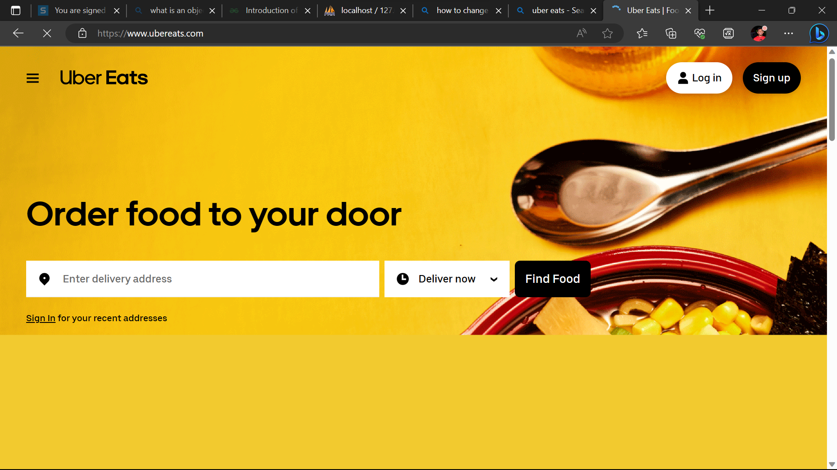

* **DoorDash**: DoorDash is a food delivery platform that partners with local restaurants to provide on-demand delivery services to customers.

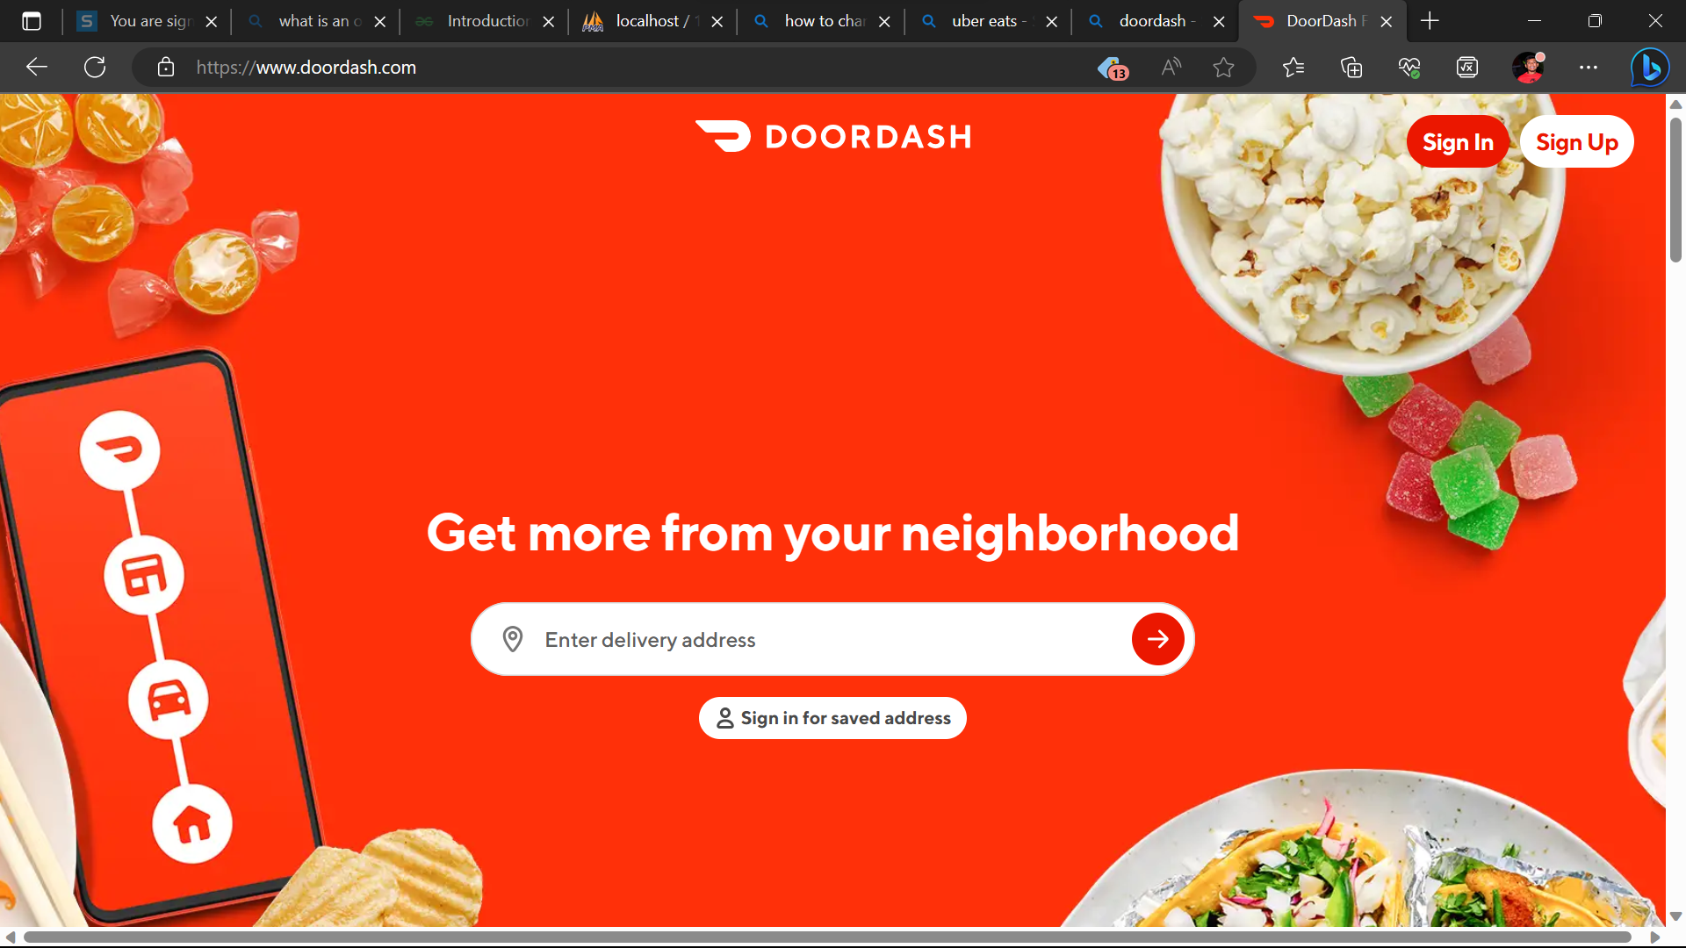

* **Grubhub**: Grubhub is a leading online food ordering and delivery platform, connecting users with local restaurants in their area.

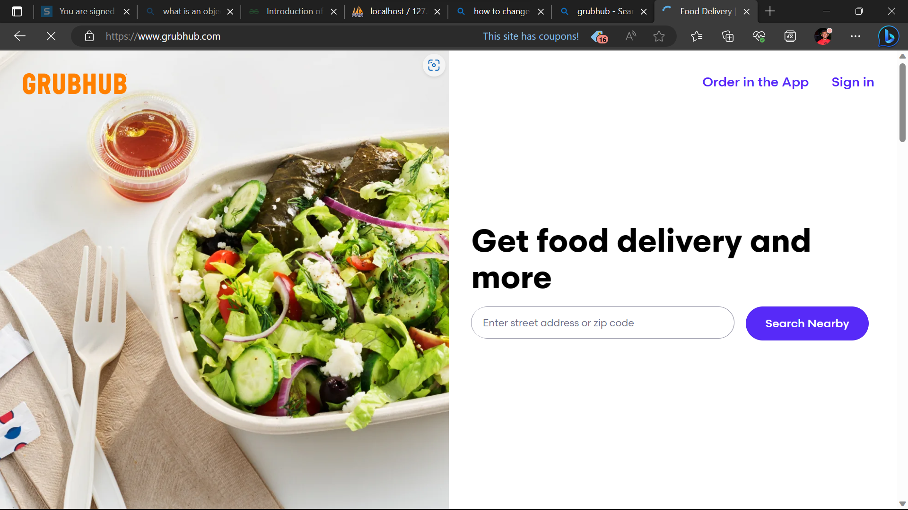

* **Postmates**: Postmates is a delivery service that offers not only food delivery but also delivery for a wide range of products, including groceries and household items.

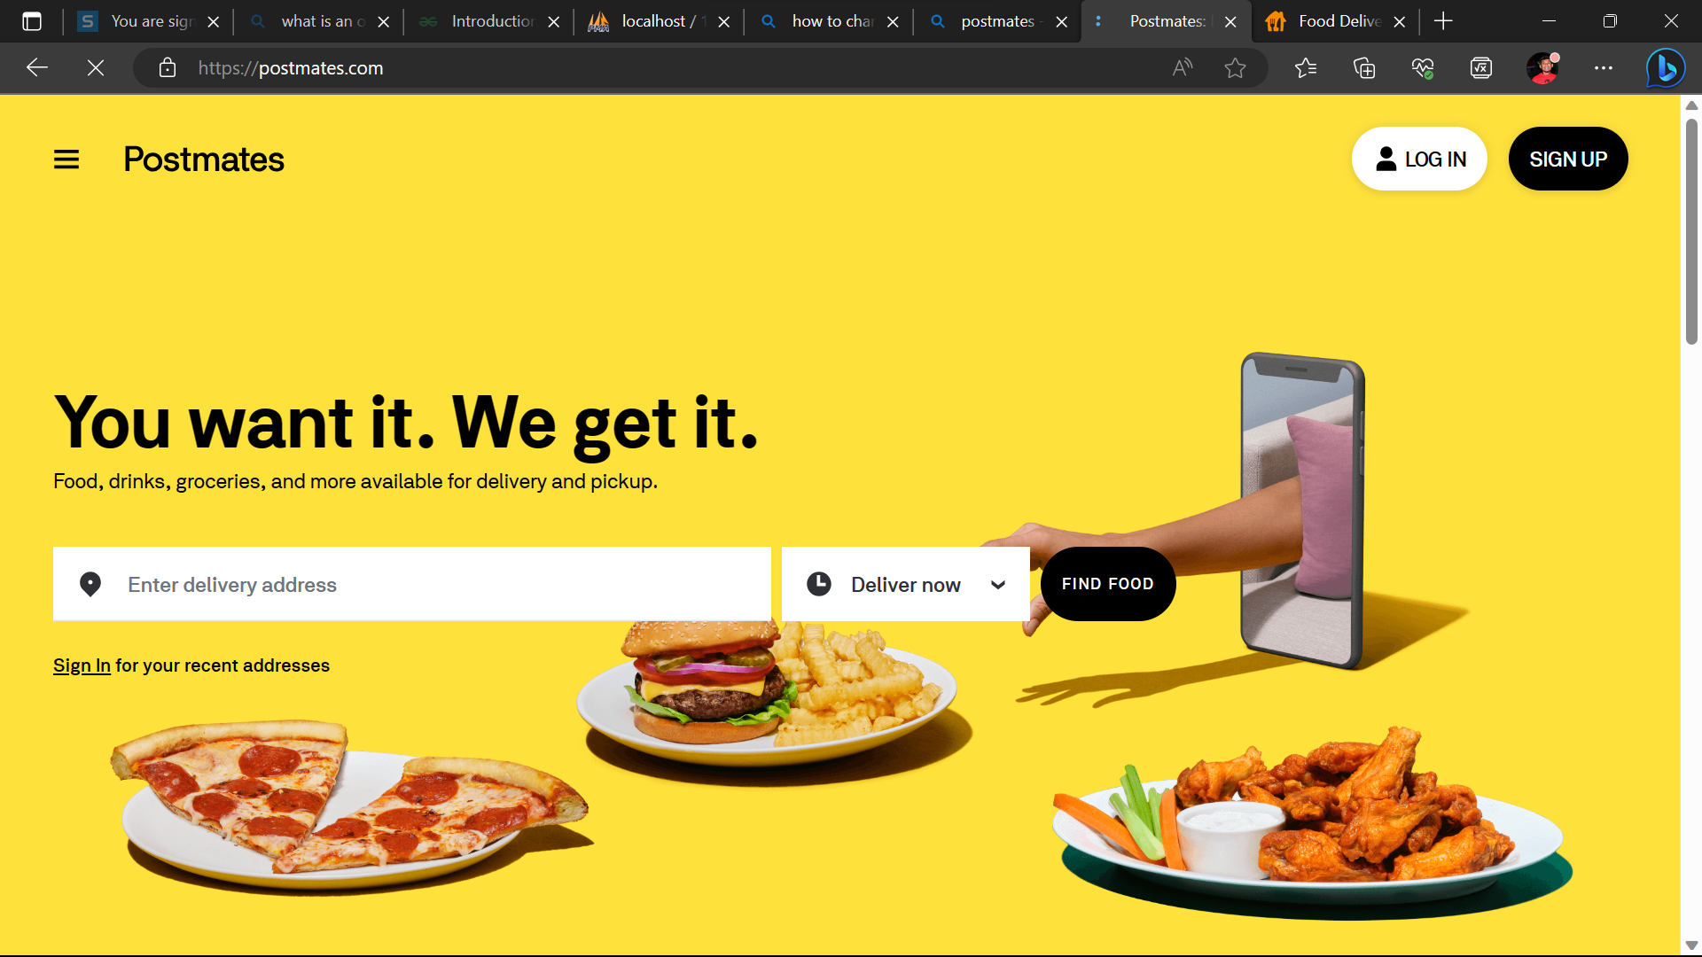

* **Deliveroo**: Deliveroo is a food delivery platform that operates in several countries, offering a variety of restaurant options and delivery services.

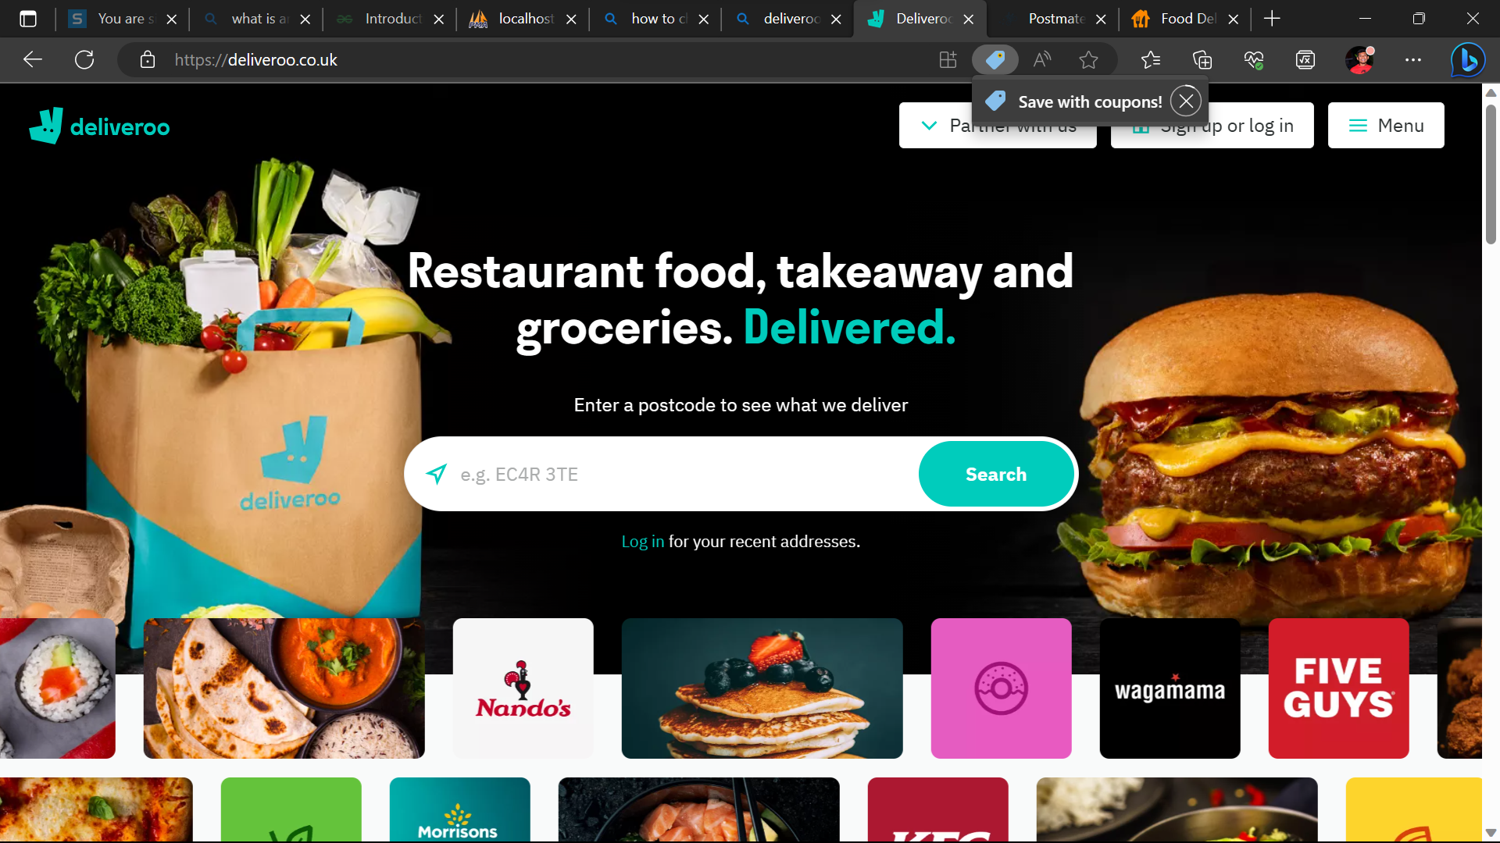

* **Zomato**: Zomato is a popular food delivery and restaurant discovery platform that operates globally, providing users with access to a vast selection of restaurants.

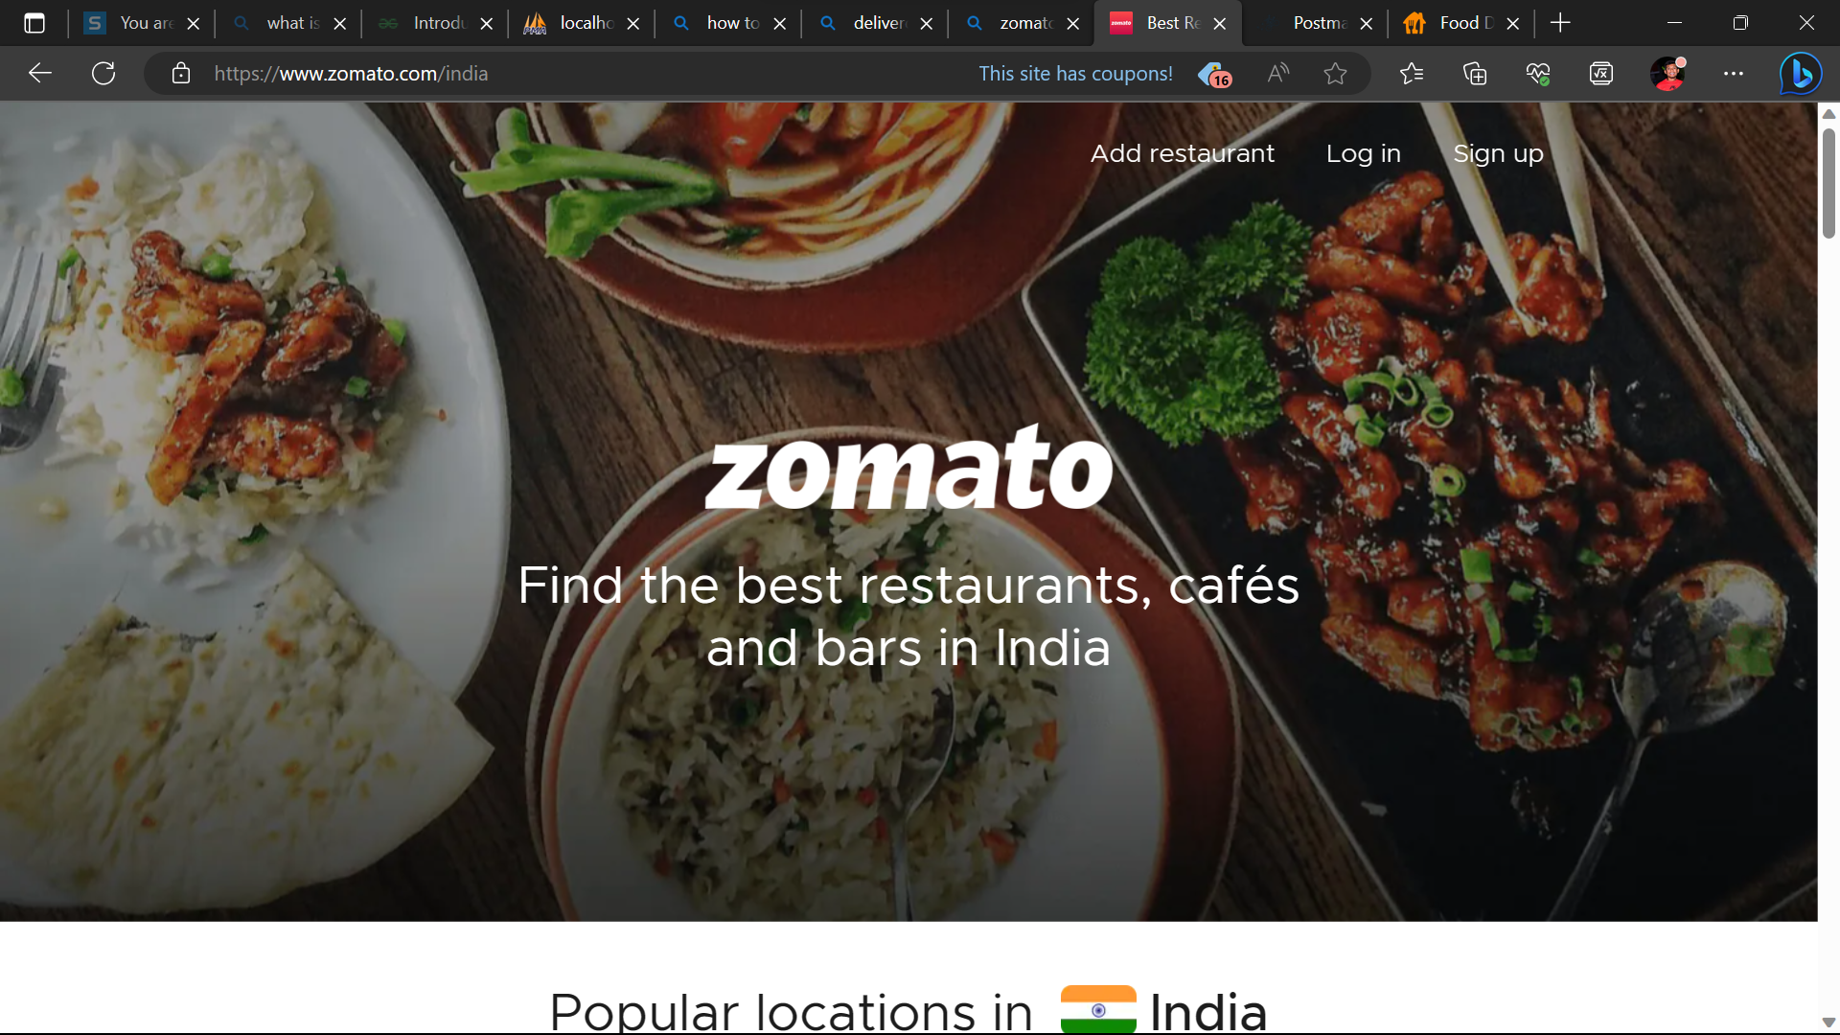

* **Swiggy**: Swiggy is a major food ordering and delivery platform in India, known for its extensive restaurant network and fast delivery services.

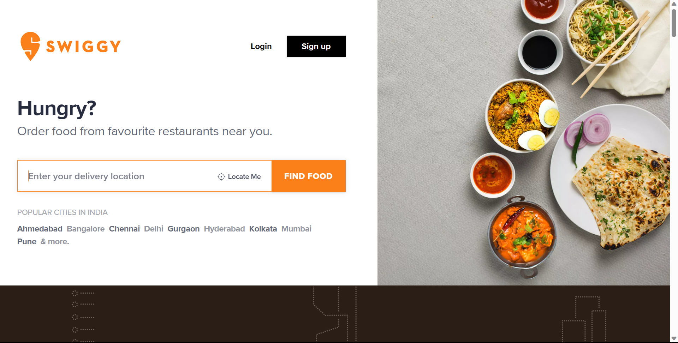

* **Just Eat**: Just Eat is a global online food delivery platform that partners with restaurants to offer delivery services to customers.

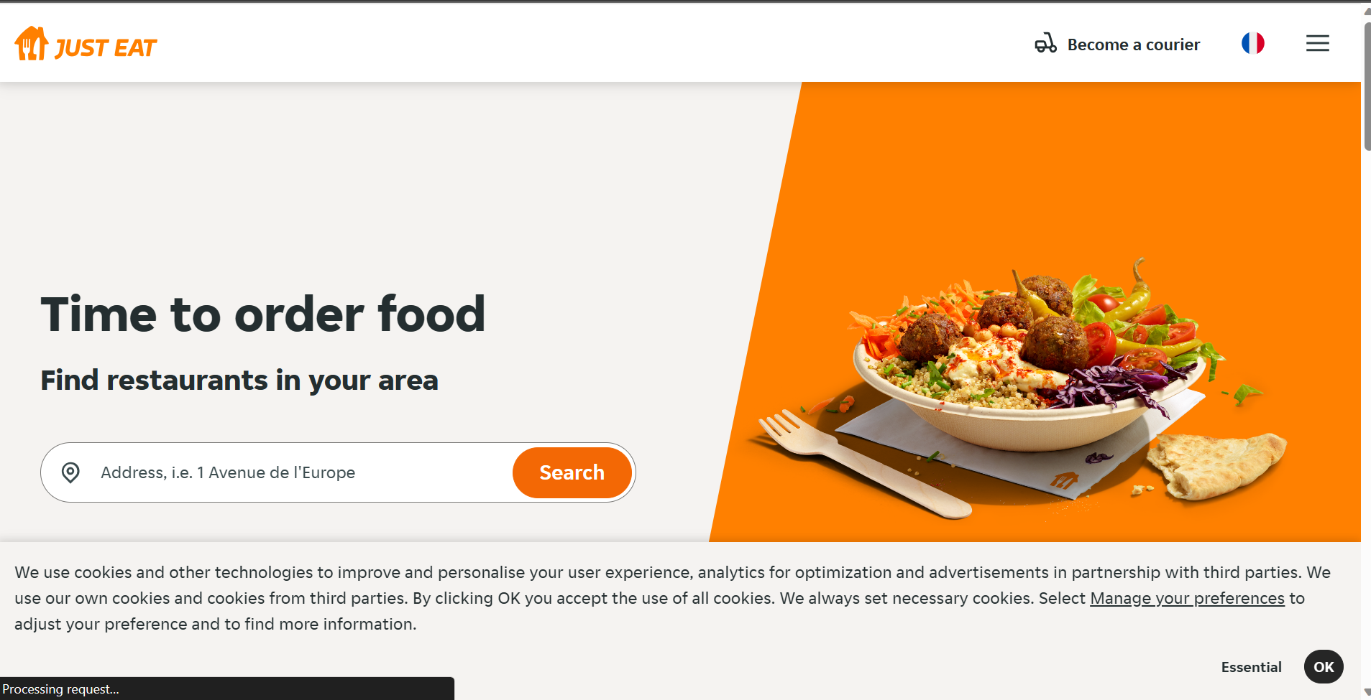

* **Foodpanda**: Foodpanda is an online food delivery platform that operates in multiple countries, connecting users with local restaurants for convenient ordering and delivery.

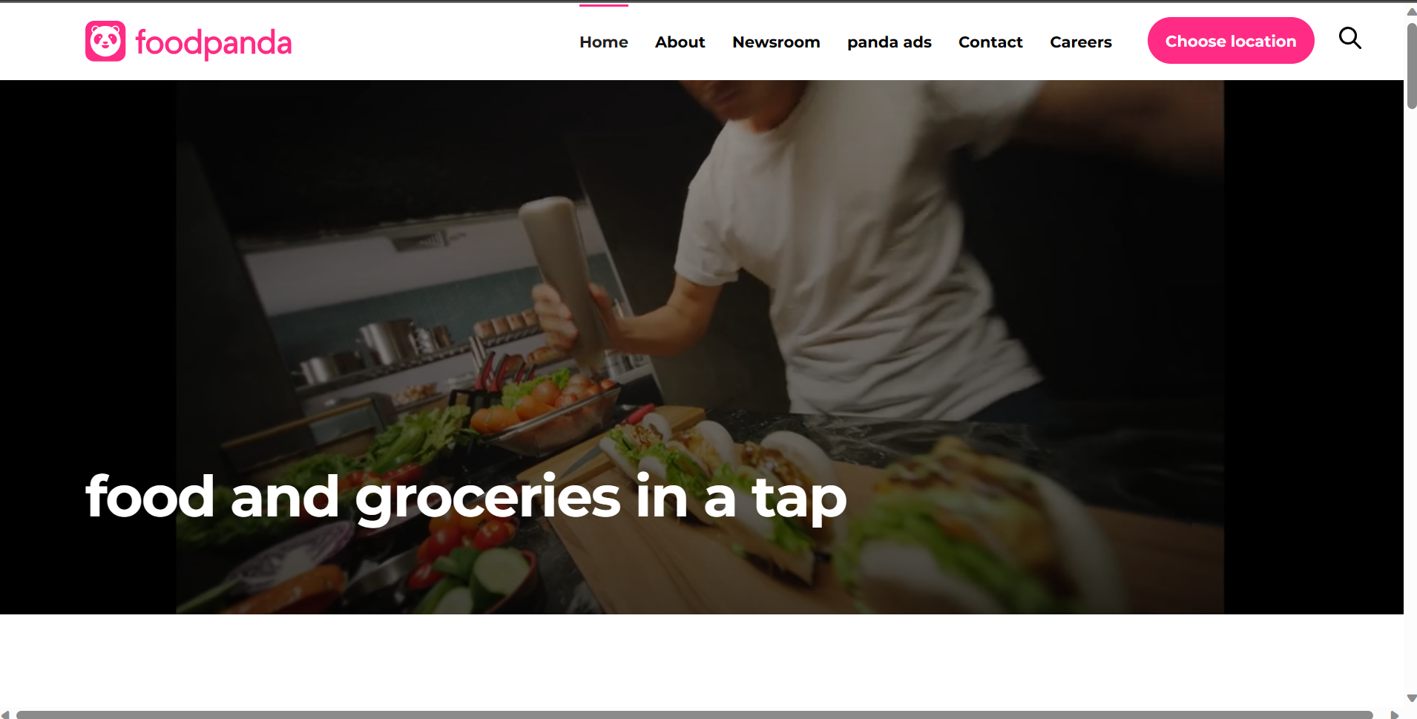

* **Seamless:** Seamless is a food delivery and takeout platform that allows users to order from a wide selection of restaurants in their area.

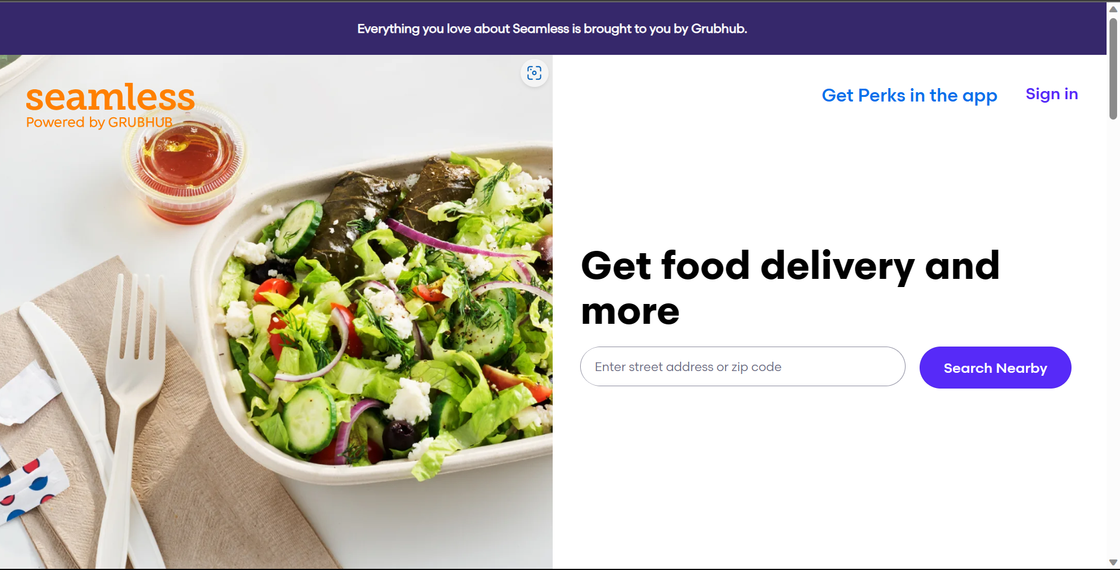

These are just a few examples of the many competitors in the food delivery and ordering industry. Each platform may have its own unique features, regional availability, and market share. It's worth noting that the competitive landscape may vary based on different geographical locations.

Our website, Food website, stands out from other food delivery and ordering websites due to its distinct features and offerings. Here are some ways in which Food website differentiates itself:

* **Food Donation Page:** Food website's special feature of a dedicated food donation page sets it apart. This platform allows users to contribute meals to those in need, providing an opportunity for users to make a positive impact on the community.

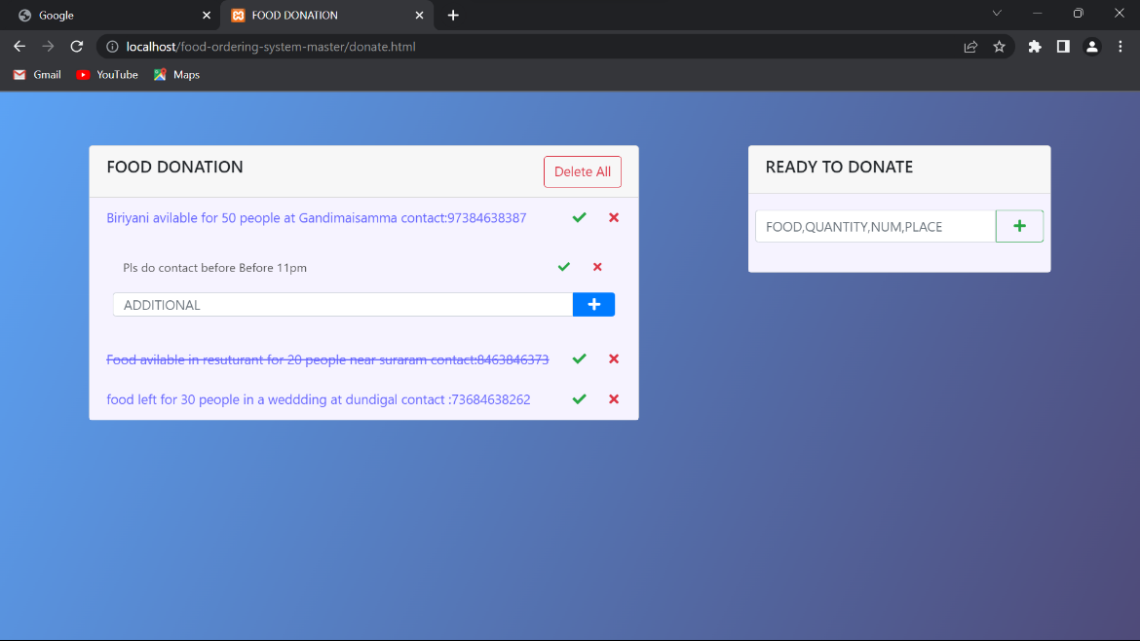

* **Administrator Access and Data Editing**: Food website grants the administrator full access to edit and manage all data, including restaurant listings, menus, and customer information. This feature enables efficient administration and ensures up-to-date and accurate information.

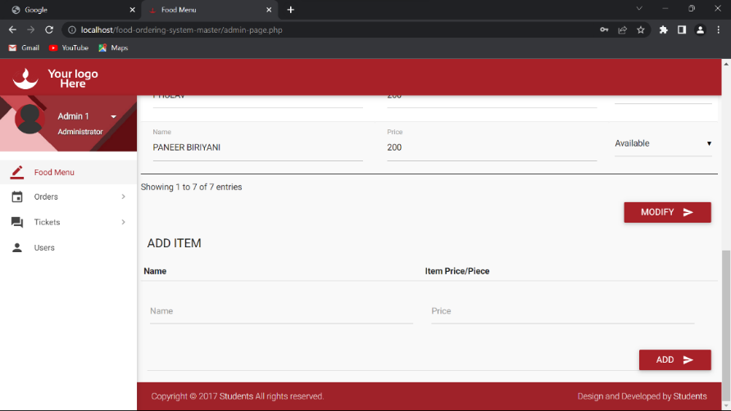

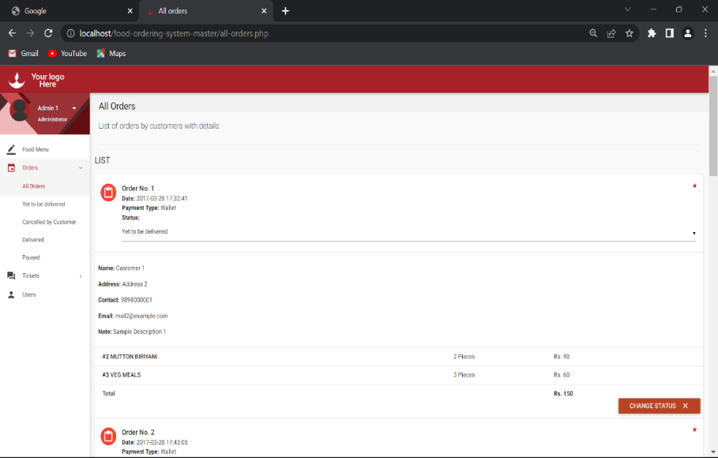

* **Ticketing System**: Food website's ticket-raising option for customers allows them to submit queries, feedback, or concerns. This feature demonstrates a commitment to customer support and ensures that customer inquiries are promptly addressed.

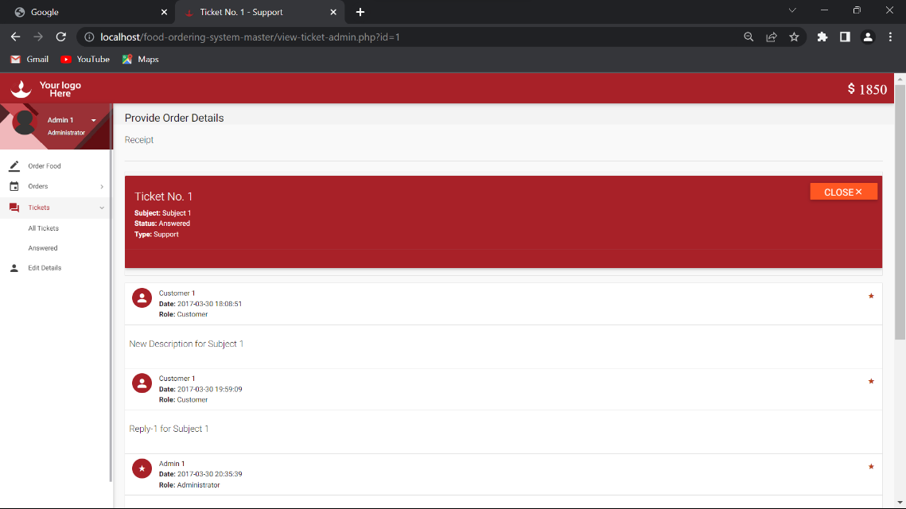

* **Wallet Option**: Food website provides a wallet feature where users can add funds to their accounts. This allows for faster and more convenient transactions and adds a level of flexibility to the payment process.

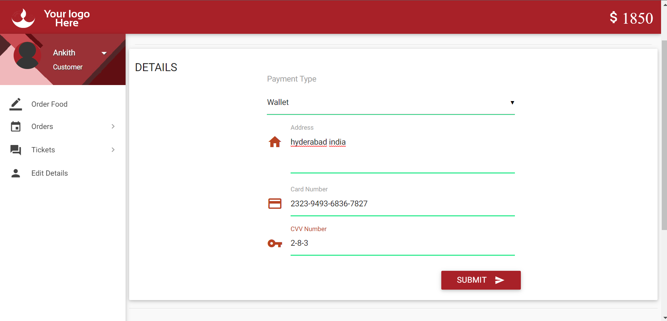

* **Cash on Delivery and Card Payment Options:** Food website offers customers both cash on delivery and card payment options. This versatility accommodates various customer preferences and enhances the overall user experience.



* **Emphasis on User Profile Management**: Food website allows customers to easily update their personal information, delivery addresses, and payment details. This feature ensures convenience and flexibility for users when placing orders.

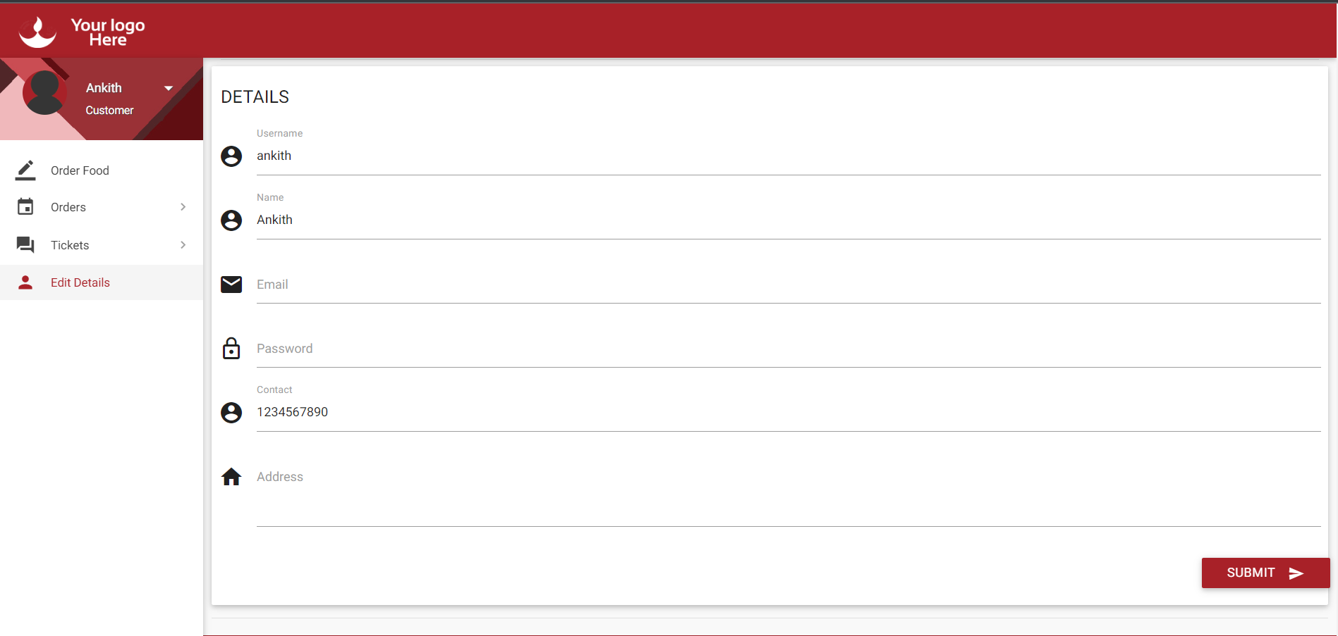

While other food delivery websites may offer some similar features, the unique combination of food donation, administrator access, ticketing system, wallet option, and user profile management sets Food website apart from its competitors. These features demonstrate Food website's commitment to providing a comprehensive and user-centric food ordering experience while addressing community needs through its food donation feature.

Conducting a literature survey for a food web application:

1. **Food Delivery and Ordering Systems**: Explore academic papers and industry reports that discuss the design, development, and challenges associated with food delivery and ordering systems. Look for studies on user experience, order management, payment processing, and logistics optimization.
2. **User Interaction and Interface Design**: Investigate research on user interaction and interface design for food ordering websites. This may include studies on usability, user experience (UX) design, and user interface (UI) design principles specifically relevant to food delivery platforms.
3. **Payment Processing and Security**: Look for literature related to online payment processing and security measures specific to food web applications. Topics may include payment gateway integration, encryption techniques, fraud prevention, and customer trust factors.
4. **Mobile Application Development**: If your food web application includes a mobile component, explore research on mobile application development, including technologies, frameworks, and best practices for creating efficient and user-friendly mobile apps.
5. **Personalization and Recommendation Systems**: Investigate literature on personalized recommendations and recommendation systems in the food delivery domain. This may involve studying techniques for analyzing user preferences, collaborative filtering, and content-based recommendations.
6. **Food Donation Platforms**: If you are focusing on the food donation feature, explore literature on food donation platforms, food waste management, and initiatives that connect donors with those in need.
7. **Operational Efficiency and Logistics**: Look for research that addresses operational efficiency and logistics optimization in food delivery systems. This may include studies on route optimization, delivery time prediction, and demand forecasting.

When conducting a literature survey, it's essential to search through academic databases, industry publications, conference proceedings, and related research papers. Additionally, you may consider reaching out to experts or professionals in the field of food delivery, web development, or related areas for their insights and recommendations.

**Conclusion:**

In conclusion, conducting a literature survey for a food web application involves exploring various research papers, industry reports, and related sources to gather information on key aspects of food delivery and ordering systems. Some important areas to focus on include user interaction and interface design, payment processing and security, mobile application development (if applicable), personalization and recommendation systems, food donation platforms, and operational efficiency and logistics optimization.

By delving into the existing literature, you can gain valuable insights into user experience, best practices in design and development, payment processing methods, security measures, mobile app development frameworks, personalized recommendations, food waste management, and logistics optimization in the food delivery domain. The literature survey helps you understand the current state of the field, identify potential challenges, and gather ideas and strategies to enhance your food web application.

Remember to explore academic databases, industry publications, conference proceedings, and seek expert opinions to ensure a comprehensive literature survey. This research will provide you with a solid foundation of knowledge to inform the design, development, and overall success of your food web application.

In conclusion, Food website is an exceptional food ordering website that sets itself apart from its competitors through its unique features and user-centric approach. With a seamless ordering process, secure card payment option, and convenient cash on delivery, Food website prioritizes customer convenience and satisfaction.

The standout feature of Food website is its dedicated food donation page, providing a platform for users to contribute meals to those in need. This emphasis on social responsibility sets Food website apart and allows users to make a positive impact on their communities.

Additionally, Food website offers an administrator access feature, enabling efficient data management and the ability to edit and update restaurant listings, menus, and customer information. This ensures accuracy and up-to-date information on the platform.

The ticketing system in Food website enables customers to raise queries, provide feedback, or seek support, with the assurance of timely resolution from the dedicated support team. This commitment to customer support enhances the overall user experience.

The wallet option allows users to add funds to their accounts, facilitating faster and more convenient transactions. Alongside this, the user profile editing feature empowers customers to update their personal information, delivery addresses, and payment details, ensuring flexibility and accuracy in their orders.

Food website stands out as a comprehensive and user-friendly food ordering website, combining convenience, security, and social impact. By offering a unique set of features, Food website delivers a differentiated experience, making it a top choice for users seeking a reliable and socially conscious food delivery platform.